The Generation of Plane/Space Curves

The last major topic we will look at in the course this year is the whole issue of generating smooth curves either through a set of points in space, or with a shape controlled by a set of points in space. Most of the examples we look at in the brief time available will in fact be restricted to a plane, though all the methods described are trivially extended to three-dimensions. Although it is not an entirely trivial operation (J), the capability of generating curves in space can be exploited in a fairly intuitive way to generate grids of curves in space, and so, eventually, to the generation of images of curved surfaces in space. We will not have time to look at these details at all in this course. However, this connection between curves and surfaces justifies looking at curve generation techniques in some detail.

Straight line segments are easy to construct: specify the locations of the two endpoints, and there are very efficient algorithms for generating the coordinates of a sequence of points between them giving the image of a straight line. On the other hand, simply knowing the coordinates of a few points on a curve does not generally give us enough information to unambiguously create the rest of the curve. It is true that images of curves on a video screen are usually constructed of a sequence of many straight line segments, each short enough that the overall image is perceived as a smooth curve, and so, one could perhaps think of specifying a curve by specifying a large number of closely spaced points along that curve. This has the disadvantages of requiring some way to compute the coordinates of that large set of points (actually the problem we are now dealing with), requiring the storage and manipulation of possibly large amounts of data, and probably most critically, being ill-suited to changing the scale of the drawing. If such a “curve” were magnified, eventually the short line segments would become visible as straight line segments, and the quality of the image of the curve would become unacceptably crude.

Instead, a variety of methods have been developed for generating formulas or equations of curves based on the locations of a relatively small number of control points. Once equations are obtained, the image can be scaled and manipulated in many other ways as desired without the quality of the image deteriorating. Equations for some familiar basic geometric curves are well-known (for example, for circular arcs, elliptical arcs, parabolas, etc. -- though the equations you find for these standard curves in textbooks may not always be very computationally efficient). However, many curved shapes in life (hence in computer graphics!) are not simple circular arcs, etc. Instead, we may either have an approximate but non-standard shape in mind, or we may wish to “play around” with the shape until some esthetic quality is achieved.

Almost all the methods make use of parametric forms of equations. This means that to describe a curve in space, we will derive formulas for x, y, and z, each in terms of some parameter, say t. Then as t varies over some specific range, the (x, y, z) coordinates of the points on the curve are generated by these formulas. (For curves in a plane, just ignore reference to z here). All of these methods start with a set of control points, the location of which determines the shape of the curve. Interpolation methods create curves which actually pass through the control points. Approximation methods (or, “curve fairing methods”, in the language used by some authors) create curves which generally do not pass through all of the control points, and may not pass through any of them, but have a shape determined by the location of these points all the same. We will look at five interpolation methods (natural cubic splines, natural quadratic “splines”, cubic cardinal splines, interpolating cubic B-Splines and polynomial curve fits). At least two of these are bad examples, and we will find generally that the interpolation problem can give rather strange looking curves. We’ll look at three major types of approximation methods (Bezier curves, cubic B-splines and quadratic B-splines). This only scratches the surface (J) of this important topic, but the B-spline approach is a tool of great utility, and a good start in developing a useful toolkit of curve generating methods. (For example, the Truetype Font glyphs so familiar to users of Microsoft Windows applications are based on a quadratic B-spline approach.)

A set of MS Excel workbooks have been created implementing each of these methods to generate results corresponding to a specific set of 8 control points. Images from each of these are reproduced in the next pages. You can experiment with the methods by simply changing the coordinates of the control points in the worksheet (and perhaps adjusting the scaling of the charts if necessary). While Excel in not the best tool for general curve generation, it does make playing around with simple examples quite easy, since most of you will be familiar with its usage.
Full Bezier Curve (BEZIER8.XLS):
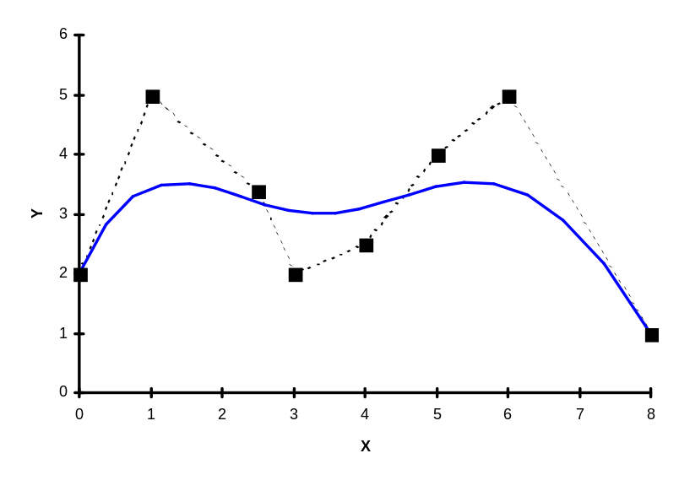
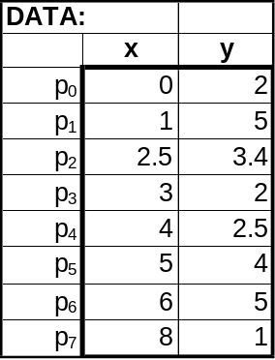

The full Bezier formula in matrix form comes out as follows in the case (L = 7, because we have 8 control points):

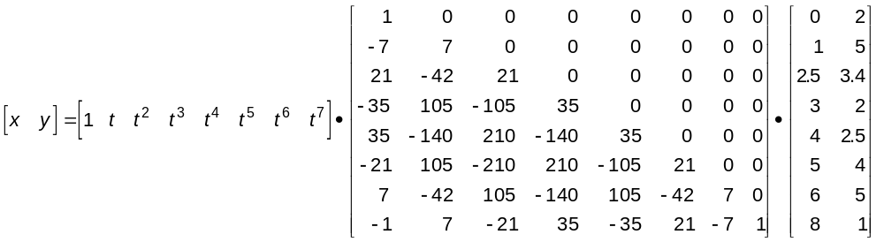
t = 0 gives the left end point of the curve (at point p₀) and t = 1 gives the right end point (at p₇). You’ll notice that the right-most matrix in the formula above is just the matrix of coordinates of the eight control points. The 8 x 8 matrix in the center is the matrix of Bernstein coefficients, and the recipe for setting this matrix up will be explained in class. As t varies from 0 to 1, this formula produces (x, y) coordinates of points along the curve.

As part of your experimenting with this formula, try to make the peaks of the curve more prominent. The obvious way to do this is to relocate, say, the second, third, sixth and seventh control points at higher y-coordinates. When you do this, what you’ll notice is that the humps become only slightly more prominent, with the major effect being just to shift the entire smooth curve upwards. This illustrate one of the major shortcomings of the full Bezier curve approach, and motivates the search for methods that construct the overall curve out of pieces, each under the control of only a few of the points at a time.

Natural Cubic Spline (NATCUB8.XLS):
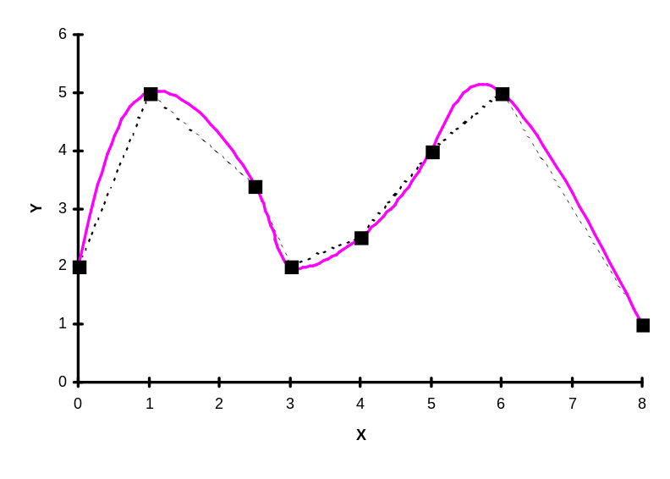
Natural Quadratic “Spline” (NATQD8.XLS):
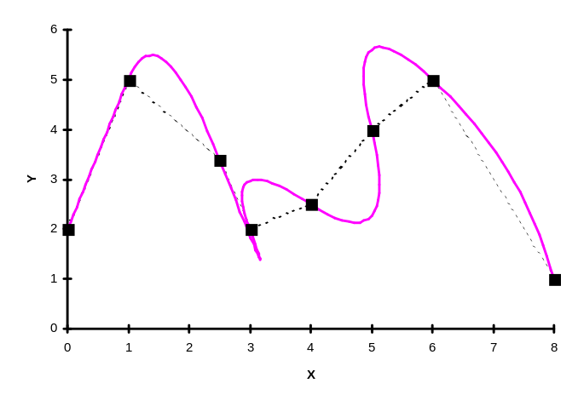
As mentioned in class, many writers would hesitate to apply the term “spline” to a curve based on quadratic or second order formulas (reserving spline to refer to cubic or third order formulas only). However, something similar to the approach used in developing the natural cubic spline formulas can be carried based on quadratic formulas:

p = a_{k} + b_{k}t + c_{k}t²

for the segment between control points p_{k} and p_{k+1}. The bolding indicates the symbols stand for pairs of values, one for the x-coordinate and one for the y-coordinate.

When the conditions that must be satisfied to get the individual segments to match at each control point and have the same direction (C⁰ and C¹ continuity) are tabulated, you find that one constant in this set of formulas is undetermined. In the formulation presented in class, we take this to be the coefficient of t² for the first segment. Choosing that coefficient to be zero gives the curve shown above. It has the interesting property that the first segment is a straight line, and then subsequent segments are curves in order to interpolate the control points. Unfortunately, this also leads to a rather wild set of oscillations about the control polyline.
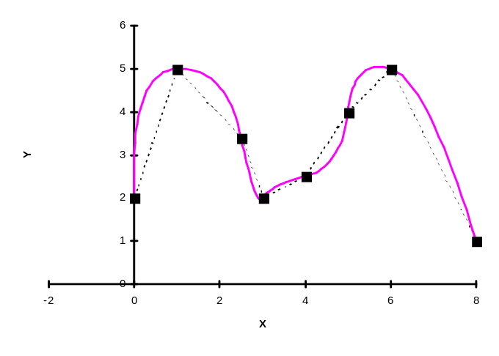
Since it is the t² terms in this formula which produce the “curviness”, one might think that making all of the constants c_{k} simultaneously as small as possible would lead to the smoothest possible curve of this type. We set up the capability in the spreadsheet to choose c₀ to minimize the sum of the squares of all of the coefficients of t² over the entire curve (just invoke Excel’s Solver tool). The result is the curve shown just to the left -- still not very pleasing. This illustrates the relative weakness of a piecewise quadratic approach to curve generation compared with the piecewise cubic approach of natural cubic splines, for example.

“Cardinal” Splines (CARD38.XLS):
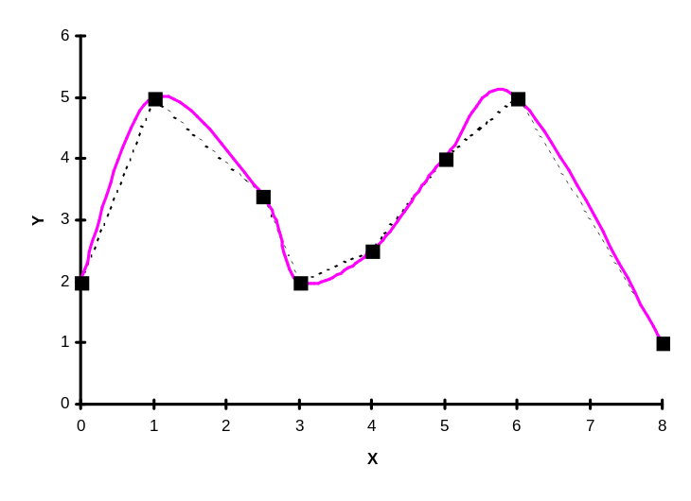
The formulas used to generate this curve were taken (with cosmetic changes only) straight from Baker & Hearn, pages 323-325. The overall curve consists of segments between each control point generated separately using the formula:
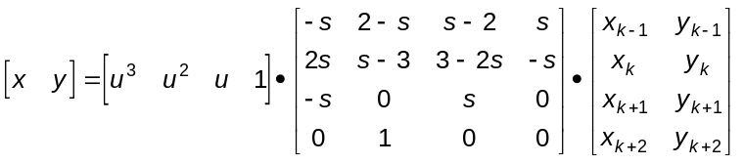

which will give the segment between control point #k and control point #k+1 as u runs from 0 to 1. Here,
s = (1-t)/2, where u is called a tension parameter. The more positive the value of t, the closer the cubic curve follows the polyline joining the control points. The illustration above uses t = 0. You can experiment with the value of t in the spreadsheet, and you’ll find that values of t is much different from zero result in rather strange shapes containing loops.

The right-most matrix is the matrix if coordinates of control points. To generate the segment from p₀ to p₁, we used p₋₁ ≡ p₀ (that is, we repeated the first point twice). Similarly, for the last segment, from p₆ to p₇, we used p₈ ≡ p₇, repeating the last point twice in this formula.

The points along this curve between two successive control points depend only on the locations of those two control points themselves, and the two control points immediately adjacent. More details of the strategy behind the above formula are found in Baker & Hearn. The formula given above results from requiring that segments join at the control points, that the direction of the curve at the left end of each segment be proportional to the direction of the line joining the first and third of the four points involved, and the direction of the curve at the right end of the segment be proportional to the direction of the line joining the second and fourth of the four points involved. This makes things match up well since the second and fourth of the four points for one segment become the first and third of the four points involved in the next segment.
Cubic B-Spline (CUBBSP8.XLS):
This is the cubic B-spline curve based on the standard (open) knot vector. For L + 1 = 8 control points, we get the overall curve as a piecing together of L-2 = 5 separate cubic segments. Only the first and last control points are interpolated, and the cross-hatches indicate the boundaries of the individual cubic segments. Notice how smooth this curve is as it manages to model the two humps quite prominently. Comparison of this picture with others in this package illustrate well why the cubic B-spline is one of the most often used in practice.
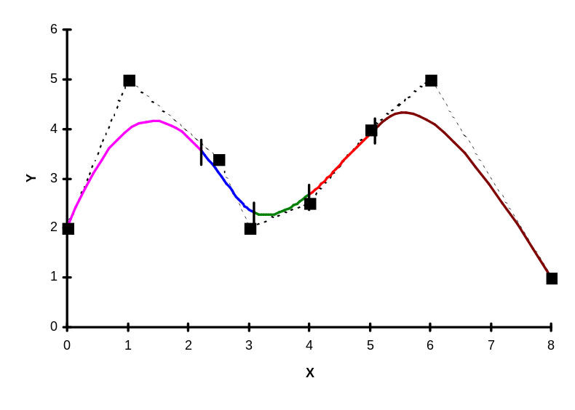

We will have spent quite a bit of time in class examining the origin of the formulas used in generating this curve. It is most convenient to “normalize” the formulas so that each segment corresponds to the parameter t varying from 0 to 1. Then, the formula for segment #k (starting from k = 0, the first segment) has the form:
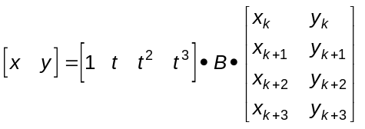

Here, the rightmost matrix is the matrix of coordinates of the four control points involved in this segment. The matrix B is a 4 x 4 matrix. It has five different versions:

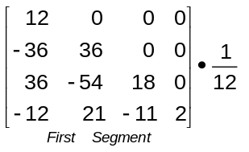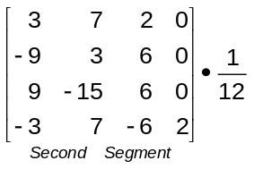

Quadratic B-Spline (QUDBSP8.XLS):
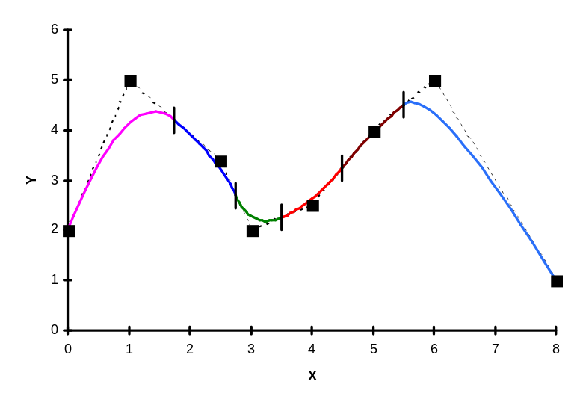
Interpolating Cubic B-Spline (INTBSP8.XLS):
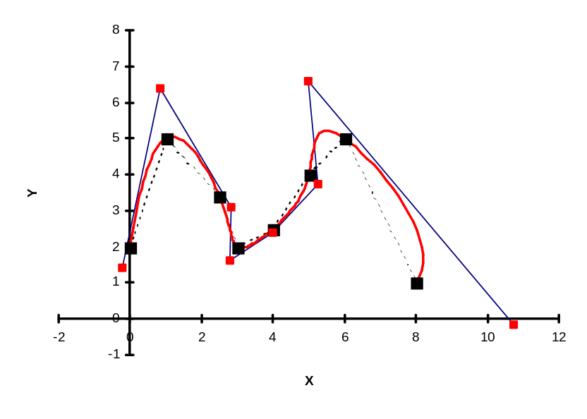
Seventh-order Polynomial Fit (POLYNOM8.XLS):
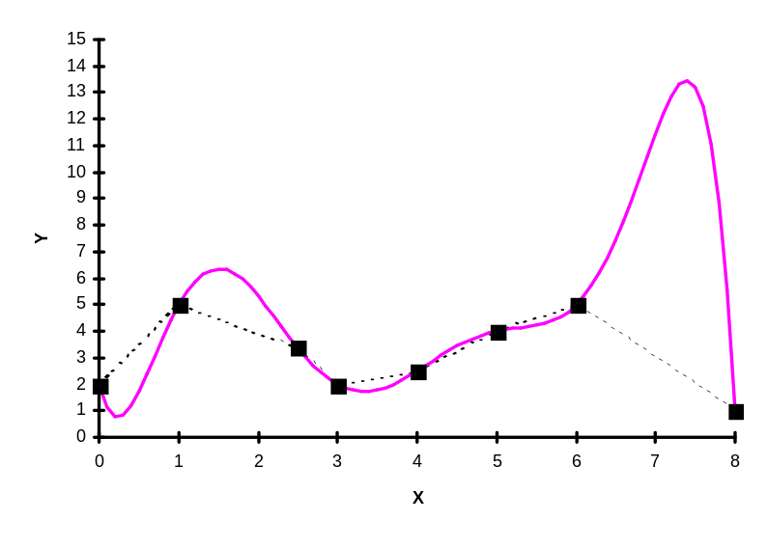
Periodic Cubic B-Spline (PERCBS.XLS):

